Names:_____________________________________________________________________
Drug Activity Circuit
Activity 1:

- How does the brain tell the lungs to slow breathing?
__________________________________________________________________________________________________________________________________________________________________________________________________________________________________________
- Name a situation that might make your heart beat fast. What drugs cause a similar reaction?
____________________________________________________________________________________________________________________________________________________________
- What are some actions that include both voluntary and involuntary responses?
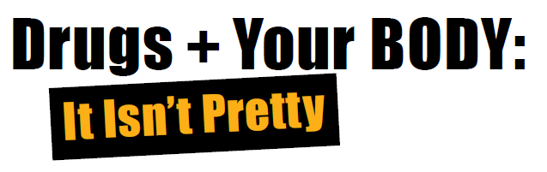
__________________________________________________________________________________________________________________________________________________________________________________________________________________________________________
Activity 2:

- Steroids affect many of the body’s organs. What are some of those organs and the effects?
________________________________________________________________________________________________________________________________________________________________________________________________________________________________________________________________________________________________________________________

- What is it about tobacco, whether smoked or chewed, that can cause cancer?
__________________________________________________________________________________________________________________________________________________________________________________________________________________________________________

- What are two drugs that can cause physical damage to the mouth and teeth? What kind of damage?
________________________________________________________________________________________________________________________________________________________________________________________________________________________________________________________________________________________________________________________
- How does alcohol damage the liver? How is this similar to the damage nicotine causes to the lungs?
____________________________________________________________________________________________________________________________________________________________________________________________________________________________________________________________________________________________________________________________________________________________________________________________
Activity 3:

Fill in the table below regarding the scenario on the task card.
 | Decide to Drink | Decide to Drive
- What is a possible negative outcome from this decision?
- What could happen to the girls and their families or even a total stranger if your outcome for A happened?
- What could be the outcome if B happened?

Based on the scenario, fill out the section below with possible outcomes:

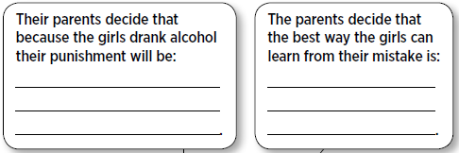

Activity 4:

- In both 2004 and 2009, which drug contributed to the most emergency room visits by people under 21?
__________________________________________________________________________

- For which drugs did emergency room visits increase from 2004 to 2009?
__________________________________________________________________________

- For which drugs did emergency room visits decrease from 2004 to 2009?
__________________________________________________________________________

- Which two drugs showed the biggest increase in emergency room visits from 2004 to 2009?
__________________________________________________________________________

- Overall, did drug-related visits to the emergency room increase or decrease from 2004 to 2009?
__________________________________________________________________________

- What are some reasons why drug abuse can cause a person to visit the emergency room? Do research as necessary to support your answer.
______________________________________________________________________________________________________________________________________________________________________________________________________________________________________________________________________________________________________________________________________________________________________________________________________

- What are some possible outcomes or costs to society that may result from drug- and alcohol-related emergency room visits?
______________________________________________________________________________________________________________________________________________________________________________________________________________________________________________________________________________________________________________________________________________________________________________________________________

