Name: _________________________ Date: ___________________

Respiratory System Review

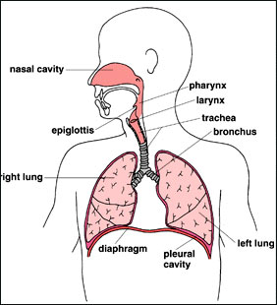
- Label the diagram below:

- Below is a diagram of a lung and it components. Label the diagram using the following words:
Cluster of Alveoli Alveolus
Capillaries Bronchiole

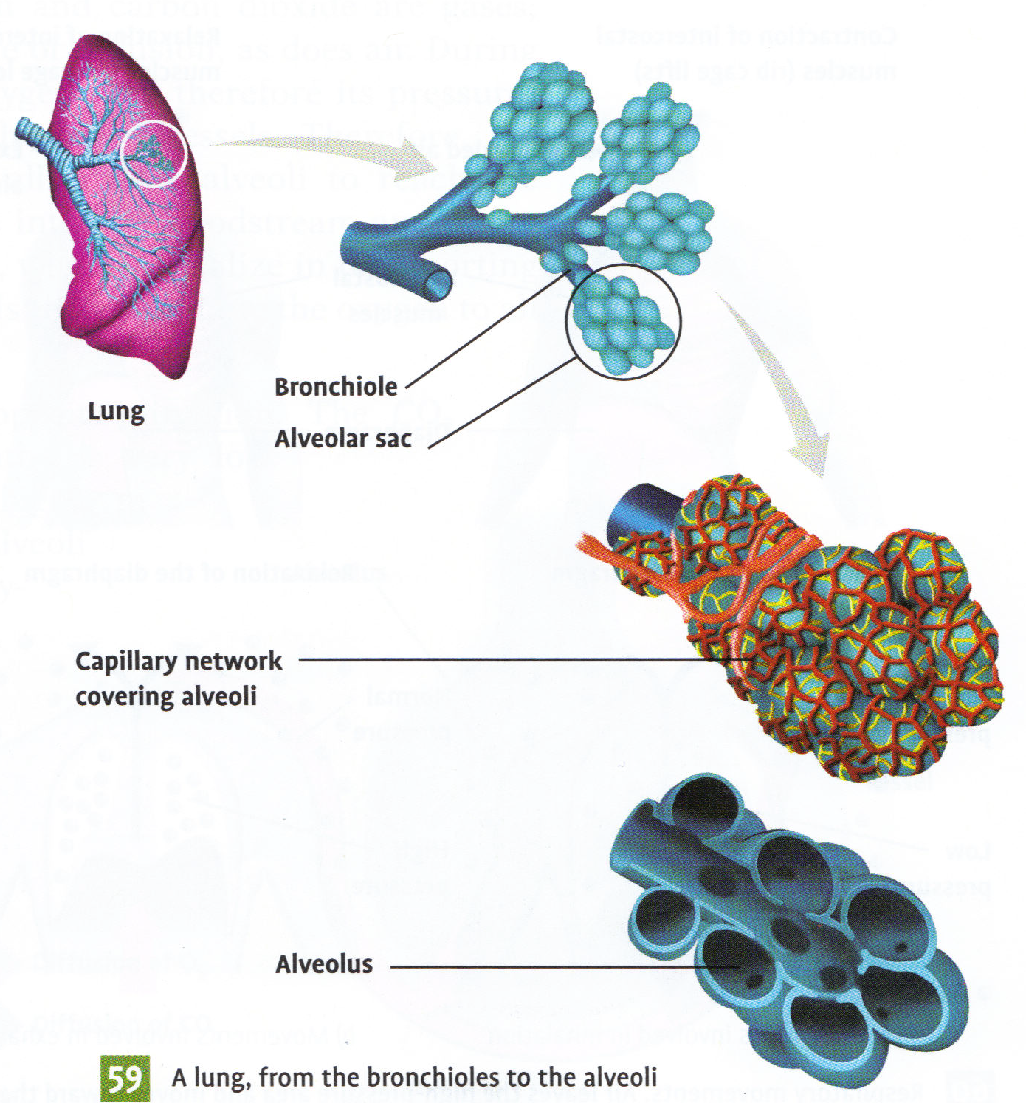

- The alveoli have two characteristics that allow for gas exchange. What are they and what gases are exchanged?

Semi permeable and can let diffusion happen, oxygen and carbon dioxide are diffused

- Place the following statements below in the order that they occur during inspiration:

- the molecule enters on of the bronchi
- the molecule enters the alveolus
- the molecule crosses the trachea
- the molecule crosses the pharynx
- the molecule enters a bronchiole
- the molecule enters the nasal cavity
- the molecule crosses the larynx

F, D, G C A E B
- In order for inspiration to occur, does the air pressure inside the lungs have to be higher or lower than surrounding air pressure? Why?

Lower, air goes from high pressure(outside) to low pressure inside

- Are the following statements true or false? If they are false, correct them.

- the only role of the circulatory system is to get rid of the carbon dioxide that our body produces
False oxygen comes in

- The diaphragm is the only muscle responsible for respiratory movements
T as well as intercostal muscles
- Red blood cells are special cells that can transport both oxygen and carbon dioxide T

- The concentration of carbon dioxide if higher in the blood that is returning to the alveoli from the body than in the air we breath

T

- The diaphragm moves back up by contracting F by relaxing

